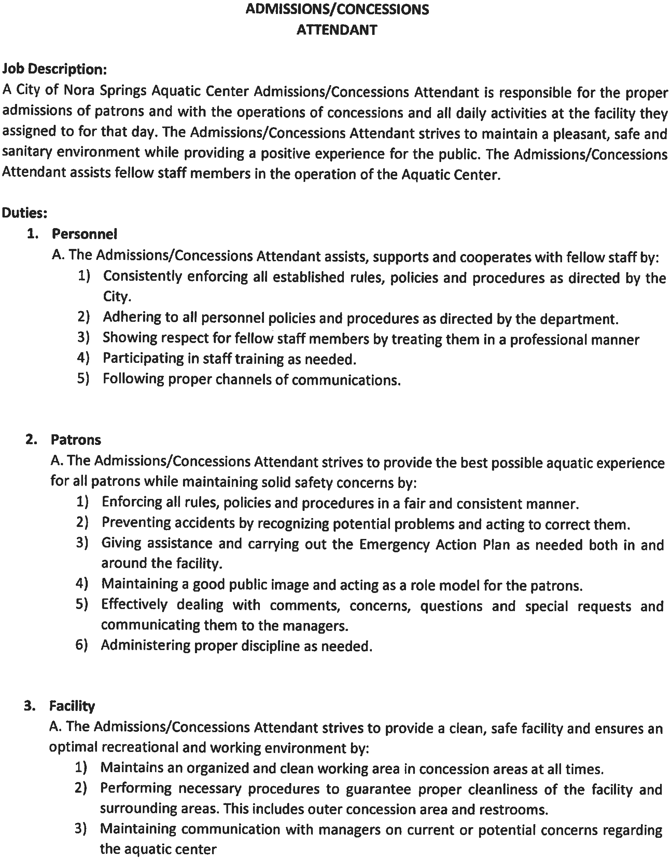
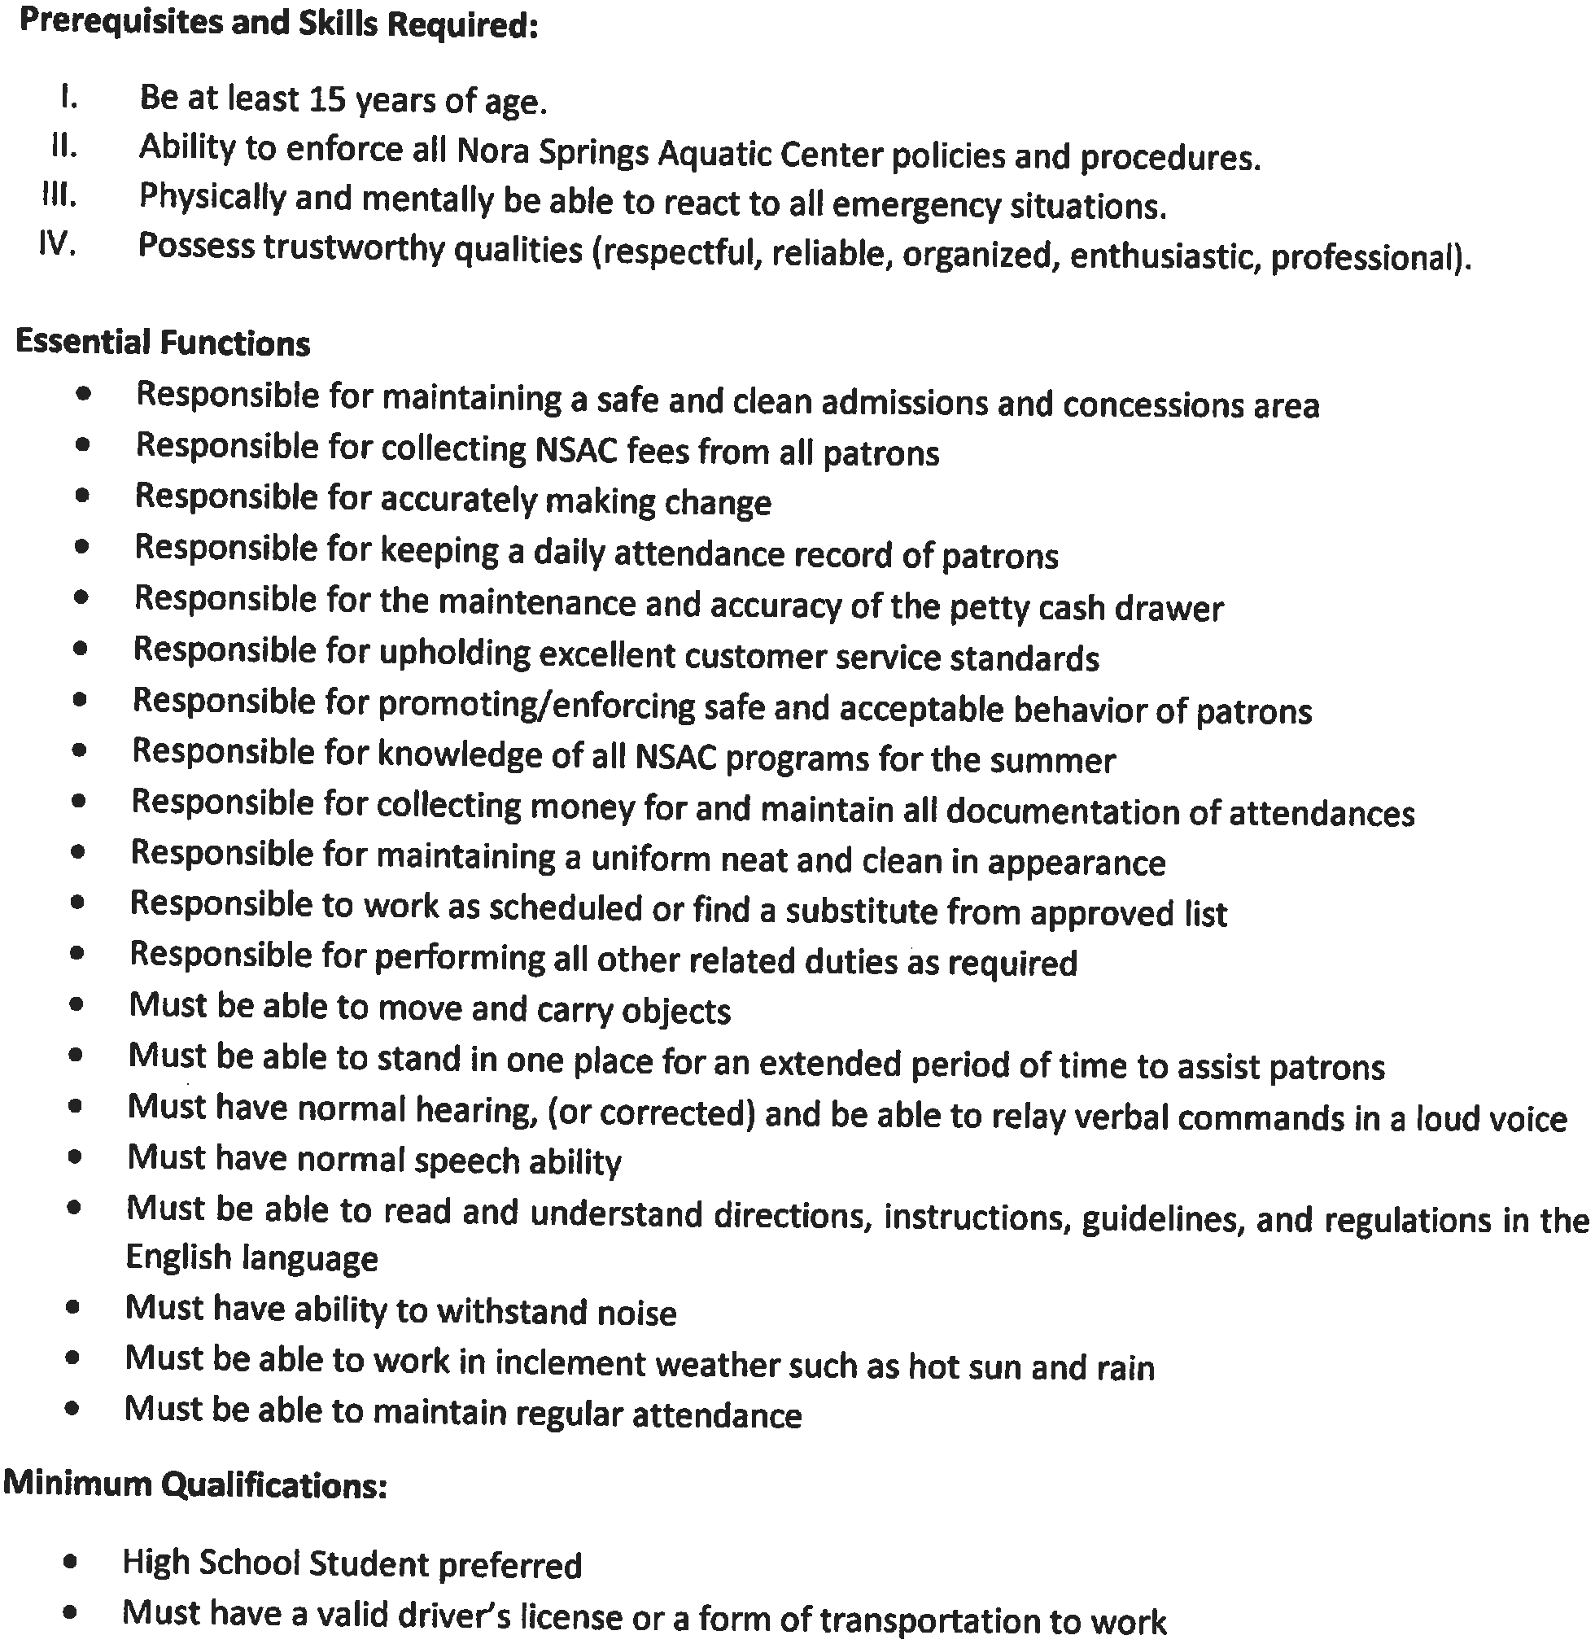
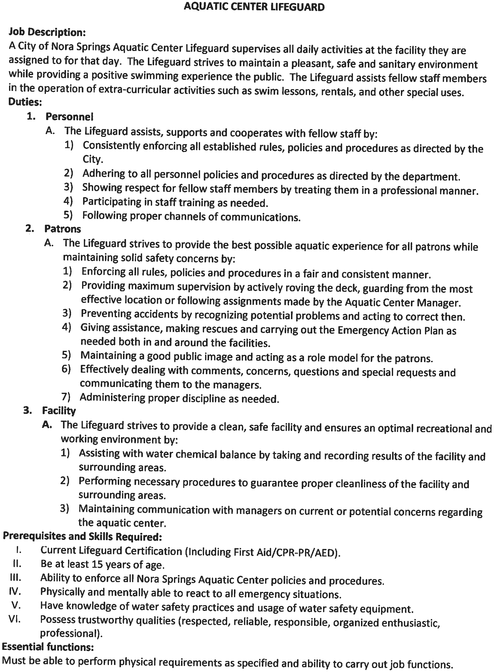
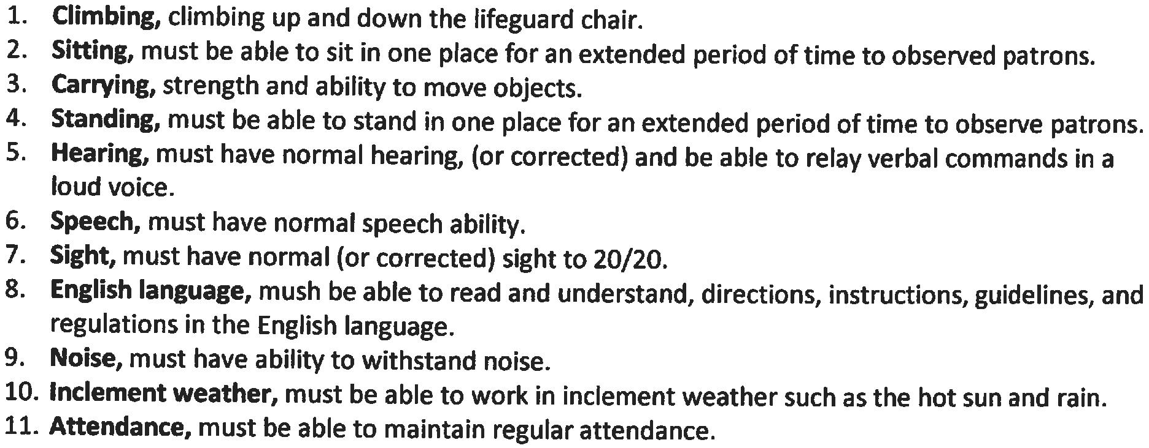
SANITATION POSITION

Job Description:
A City of Nora Springs Aquatic Center Sanitation Position employee is responsible for the proper cleaning and sanitizing of the Nora Springs Aquatic Center. The Sanitation Position strives to maintain a pleasant, safe, and sanitary environment while providing a positive experience for the public.

Duties:
1. Personnel
A. The Sanitation Position assists, supports, and cooperates with fellow staff by:
- Consistently enforcing all established rules, policies, and procedures as directed by the City and enforced by Pool Managers.
- Adhering to all personnel policies and procedures as directed by the department.
- Showing respect for fellow staff members by treating them in a professional manner.
- Participating in staff training as needed.
- Following proper channels of communication.

2. Patrons
A. The Sanitation Position strives to provide the best possible aquatic experience for all patrons while maintain solid safety concerns by:
- Enforcing all rules, policies, and procedures in a fair and consistent manner.
- Preventing accidents by recognizing potential problems and acting to correct them.
- Giving assistance and carrying out the Emergency Action Plan as needed both in and around the facility.
- Maintaining a good public image and acting as a role model for the patrons.
- Effective dealing with comments, concerns, questions, and special requests and communicating them to the managers.
- Administering proper discipline as needed.
3. Facility
A. The Sanitation Position strives to provide a clean, safe facility, and ensures an optimal recreational and working environment by:
- Maintains an organized and clean working area at all times.
- Performing necessary procedures to guarantee proper cleanliness of the facility and surrounding areas.
- Maintaining communication with managers on current or potential concerns regarding the aquatic center.

Prerequisites and Skills Required:

I. Be at least 16 years of age.
II. Ability to enforce all Nora Springs Aquatic Center policies and procedures.
III. Physically and mentally be able to react to all emergency situations.
IV. Possess trustworthy qualities (respectful, reliable, organized, enthusiastic, and professional).

Essential Functions:
- Cleaning/sanitizing bathrooms
  - Stall door handles
  - Toilets
  - Shower Stalls
  - Counters
  - Sinks
- Cleaning/sanitizing all high-touch surfaces
  - Door Handles
  - Countertops
  - Picnic Tables
  - Pool Ladders
  - Handrails
  - Lounge Chairs
- Responsible for maintaining a uniform neat and clean in appearance
- Responsible to work as scheduled or find a substitute from approved list
- Must be able to move and carry objects
- Must be able to read and understand directions, instructions, guidelines, and regulations in the English language
- Must have ability to withstand noise
- Must be able to work in inclement weather such as hot sun and rain
- Must be able to maintain regular attendance
- Other duties as assigned

Minimum Qualifications:

- High School Student preferred
- Must have a valid driver’s license or a form of transportation to work

